CONVENTION ON THE CONSERVATION OF EUROPEAN WILDLIFE

AND NATURAL HABITATS

**Standing Committee**

34tu meeting

Strasbourg, 2-5 December 2014

__________

**Follow-up of Recommendation No. 25 (1991) on the conservation of natural areas outside protected areas proper**

**REPORT BY THE Netherlands**

**Regional planning policy conserving environments and habitats**

In the National Policy Strategy for Infrastructure and Spatial Planning (SVIR), the Dutch government identifies conservation and protection of species as an important national interest (I&M 2012). The government continues to develop the National Ecological Network (NEN) as the most important remedy to stop biodiversity loss. The NEN is a network of protected areas not only of the A and B but also C and D categories (Council of Europe, 1973). The SVIR gives the NEN a spatial regime called ‘*nee, tenzij*’, which means ‘No development unless overriding reasons of regional or national interest prevail’. This regime protects nature within the network against harmful spatial development plans. Regional governments have incorporated the NEN in their spatial regulations. All spatial plans need to take into account natural values, and if there are no alternatives mitigation and compensation measures have to be taken. Agricultural land within the NEN can be managed using modern methods whilst biodiversity is at the same time protected through the implementation of measures that involve an agricultural scheme which offers financial compensation for loss of production. Around 11,500 hectares of the 547,500 hectares covered by the NEN have specific measures in place to protect biodiversity as part of the agricultural scheme.

In addition natural areas outside the NEN and agricultural areas with specific natural values such as meadow birds are protected by spatial regulations. In the meadow bird areas in Friesland, for example, all spatial plans that cause disturbance or affect openness of landscape are prohibited (Fryslân, 2014). When the developments proposed within the spatial plans are considered more important than the present natural values, the natural values lost have to be compensated.

**Regional planning conserving landscape values**

Characteristic landscape (and cultural historic) values are part of regional planning policy. These values are protected in the provincial spatial regulations by a spatial regime called ‘*ja, mits*’, which means ‘Yes development can take place, on condition that landscape values are recognised and losses to these values are kept to a minimum. Hence, spatial plans have to take into account landscape values and these values should as far as possible be integrated into any development that takes place. The provincial government has made maps of these characteristic landscape values in order that they can be more easily included in decision making. Municipalities are obliged to make a thorough assessment and deliberation considering these values when making their spatial development plans.

Since 2012, the twenty National Landscapes in the Netherlands are no longer part of national policy, but provinces are free to continue this former policy on their own (I&M, 2012). Some provinces continue with the identity of National Landscapes, others protect only their landscape values such as openness, historic landscape elements, ditch patterns etc. Some of the National Landscapes have become part of the regional identity of their inhabitants and their names are used for marketing purposes in order to attract tourists and inward investment (e.g. Noordelijk Friese Wouden).

**Agri-environmental schemes**

Measures are taken to protect natural values on around 60.000 hectares of agricultural land (figure 1); mostly nesting and rearing places for meadow birds such as Black-tailed Godwit (*Limosa limosa*) and Lapwing (*Vanellus vanellus*). Despite measures taken, the population of farmland birds is declining. The "farmland bird indicator" has declined by 15% since 2000 (figure 2). This indicator is the national version of the "Farmland Bird Indicator" (FBI) of the European Union.

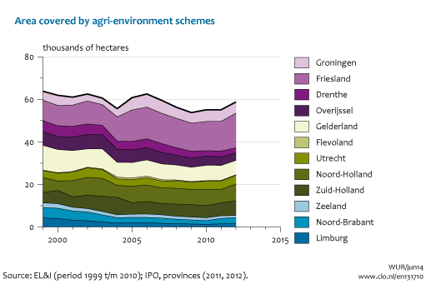

*Figure 1. The trend in area covered by agri-environmental schemes per Province (CBS et al., 2014a).*

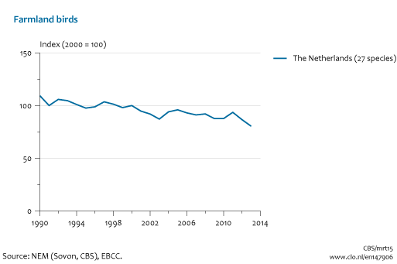

*Figure 2. The population trend of 27 farmland bird species (CBS et al., 2014b).*

**Nature development; enlargement and natural corridors**

Natural habitat is restored on agricultural land by replacing the nutrient rich top soil, restoring natural landscape relief, changing the water table, etc. In 2013 almost 70,000 hectare of new nature was developed on agricultural land (figure 3). These new nature reserves enlarge existing reserves and realize natural corridors linking natural areas. The agreed target is to develop at least 80,000 ha of new natural areas between 2011 and 2027 (EL&I, 2013).

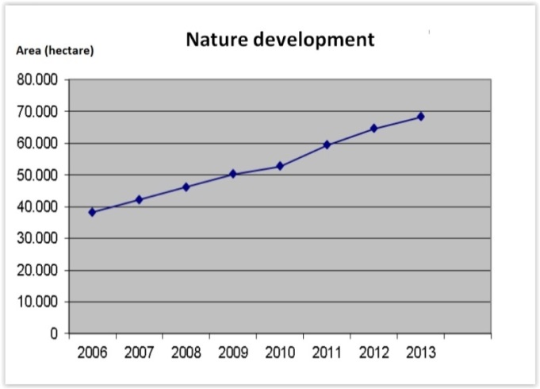

*Figure 3. Trend in area of nature development (TK 30825, nr. 214).*

**Legislation to conserve wildlife breeding, nesting and feeding places**

The main laws for nature conservation in the Netherlands are the 1998 Nature Conservation Act (‘Natuurbeschermingswet’) and the Flora and Fauna Act (‘Flora- en faunawet’). Both are the Dutch interpretation of the European Birds and Habitats Directives. The Nature Conservation Act provides for the designation of nature areas of national or international importance (Natura 2000 sites). The Dutch Flora and Fauna Act protects not only around 500 plant and animal species but also the area they live in: their nesting, resting or feeding places. These places are also protected outside the protected areas. Many of the species with most derogations have their habitat outside the protected areas (see table). When there is no alternative for activities that destroy these nesting, resting and feeding places, mitigation and compensation measures might be in order before dispensation is given.

*Table 1. Top ten species with most derogations requests in 2009 and 2010 (Veen et al., 2011).*



Many organisations, such as municipalities, water authorities, nature management, seaports, etc. work with a code of conduct. This code states how to prevent or minimize damage to protected plants and animals and their nesting, resting and feeding places during the course of recurring management work. Sectors, organizations or trade associations may draw up their own codes of conduct, which must then be approved by the Minister of Economic Affairs (EZ).

**Water bodies and the European Water Framework Directive**

The European Water Framework Directive (WFD) is a European law which obliges all Member States to have good water quality in all their major water systems by the year 2027. Measures are taken by the Dutch Ministry of Infrastructure and the Environment (Rijkswaterstaat), Water Boards, etc. to improve biological (figure 4), physical and chemical quality (figure 5) of all major water bodies inside and outside protected nature areas. Measures are for example to ban disposal of waste water and to establish nature-friendly banks of canals, rivers and ditches.

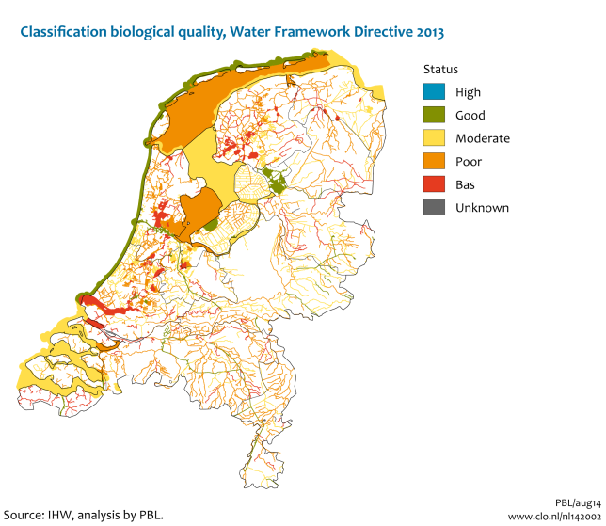

*Figure 4. The biological quality of waterbodies based on criteria of the Water Framework Directive (CBS et al., 2014c).*

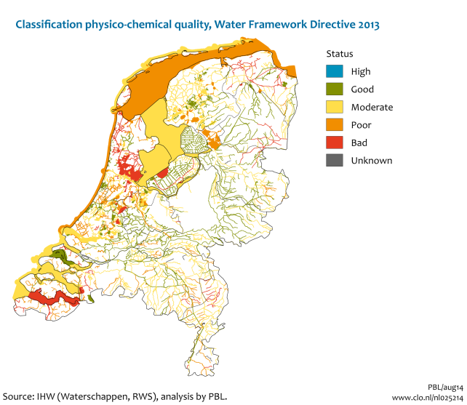

*Figure 5. The physical and chemical quality of waterbodies based on criteria of the Water Framework Directive (CBS et al., 2014d).*

**Fish migration**

Healthy fish populations are an indicator for the ecological functioning of our rivers, canals, ditches and other waters. All fish should be able to migrate between their habitat and spawning areas. However, many weirs, locks and water pump stations are an obstacle for migration and may significantly damage fish populations. The Dutch Ministry of Infrastructure and the Environment (Rijkswaterstaat), Water Boards, Provinces, Municipalities and other regional partners are working together to lift barriers for fish migration (figure 6) and our waterway network is becoming more and more reconnected (figure 7).

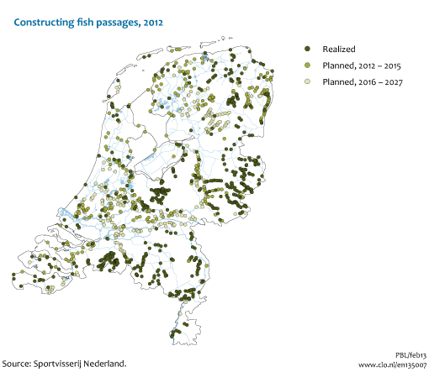

*Figure 7. Locations where barriers for fish migration are eliminated by constructing fish passages (CBS et al., 2014e).*

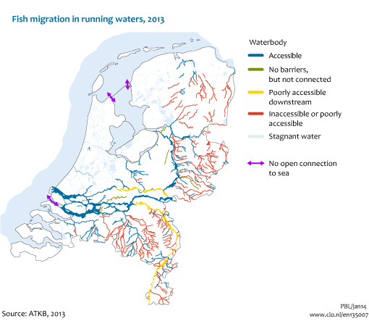

*Figure 6. Accessibility of waterbodies for fish migration in 2013 (CBS et al., 2014e).*

**‘Room for the River’**

The Dutch Ministry of Infrastructure and the Environment and the Ministry of Economic Affairs agreed to work together to increase public safety and nature development in the river region (TK 25017, nr. 29). The agreement consists of several programmes and one of them resulted in the National Spatial Planning Key Decision (PKB) ‘Room for the River’ (TK 30080, nr. 23). Flood protection is a very high priority in water management. In 1993 and 1995 the Dutch rivers swelled to unprecedented levels. The Dutch government therefore took measures, such as dike relocation, lowering of floodplains, creation of water storage areas to protect the rivers region against flooding. The maximum discharge capacity should increase from 15,000 m3/sec to 16,000 m3/sec on completion in 2015. Protection against flooding and nature development resulted in 4021 hectares (NURG 1-1-2014) of new nature in the floodplain (Groot project EHS).

**Barriers and fragmentation in the Dutch National Ecological Network.**

The multi-year defragmentation programme (Meerjarenprogramma Ontsnippering or MJPO) has identified 215 obstacles caused by national infrastructure. The target of the programme is to eliminate these obstacles by 2018 at the latest. Efforts to eliminate them involve measures like green bridges, wildlife underpasses, eco-culverts, wildlife overpasses at tree crown level and hop-overs. Thus, by 1 January 2013, about 32% of the 215 obstacles in the Dutch National Ecological Network caused by national infrastructure had been completely eliminated (figure 8), while 26% had been partially eliminated.

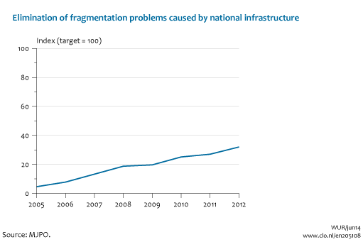

*Figure 8 Results of the multi-year defragmentation programme (CBS et al., 2014f).*

**Sources**

* CBS, PBL, Wageningen UR (2014a). Realisatie nieuwe EHS - agrarisch natuurbeheer, 1999 - 2012 (indicator 1317, versie 10, 9 juli 2014). www.compendiumvoordeleefomgeving.nl. CBS, Den Haag; Planbureau voor de Leefomgeving, Den Haag/Bilthoven en Wageningen UR, Wageningen.
* CBS, PBL, Wageningen UR (2014b). Vogels van het boerenland, 1990-2013 (indicator 1479, versie 06, 17 september 2014). www.compendiumvoordeleefomgeving.nl. CBS, Den Haag; Planbureau voor de Leefomgeving, Den Haag/Bilthoven en Wageningen UR, Wageningen.
* *CBS, PBL, Wageningen UR (2014c). Biologische kwaliteit oppervlaktewater, 2013 (indicator 1420, versie 02, 9 september 2014). www.compendiumvoordeleefomgeving.nl. CBS, Den Haag; Planbureau voor de Leefomgeving, Den Haag/Bilthoven en Wageningen UR, Wageningen*
* *CBS, PBL, Wageningen UR (2014d). Algemene fysisch-chemische kwaliteit oppervlaktewater KRW, 2013 (indicator 0252, versie 14, 27 november 2014). www.compendiumvoordeleefomgeving.nl. CBS, Den Haag; Planbureau voor de Leefomgeving, Den Haag/Bilthoven en Wageningen UR, Wageningen.*
* *CBS, PBL, Wageningen UR (2014e). Migratiemogelijkheden voor trekvissen, 2012 (indicator 1350, versie 07, 4 juni 2014). www.compendiumvoordeleefomgeving.nl. CBS, Den Haag; Planbureau voor de Leefomgeving, Den Haag/Bilthoven en Wageningen UR, Wageningen.*
* *CBS, PBL, Wageningen UR (2014f). Barrières en versnippering van de Ecologische Hoofdstructuur, 2005-2012 (indicator 2051, versie 08, 23 april 2014). www.compendiumvoordeleefomgeving.nl. CBS, Den Haag; Planbureau voor de Leefomgeving, Den Haag/Bilthoven en Wageningen UR, Wageningen.*
* *Council of Europe (1973) Resolution 73 (30) ON THE EUROPEAN TERMINOLOGY FOR PROTECTED AREAS of the Committee of Ministers of the Council of Europe of 26 October 1973.*
* *EL&I (2013). Kamerbrief, kenmerk DGNR-NB / 13157005 Ministerie van Economische Zaken, Landbouw en Innovatie. Bijlage Natuurpact.*
* *Fryslân (2014). Verordening Romte. Provincie Friesland.*
* *I&M (2012). Structuurvisie Infrastructuur en Ruimte. Ministerie van Infrastructuur en Milieu. Den Haag.* (Structural Vision on Infrastructure and Spatial Planning).
* *Veen, M.P. van, M.E. Sanders, M.E.A. Broekmeyer (2011). Ecologische effectiviteit van natuurwetgeving (Dutch National legislation that gives effect to the Habitats Directive). PBL-publicatienummer: 5555084002. The Netherlands Environmental Assessment Agency, Bilthoven*